ASSIGMENT 1

Day 1

WORKING WITH IAM

(BY - Kshitize Mangla)

1. Create 3 users –

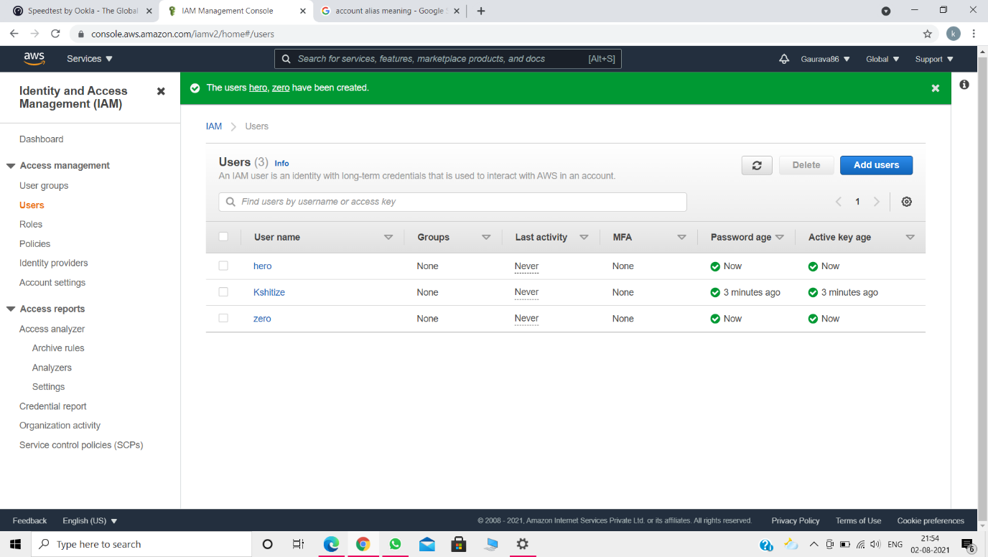

1. Create one group 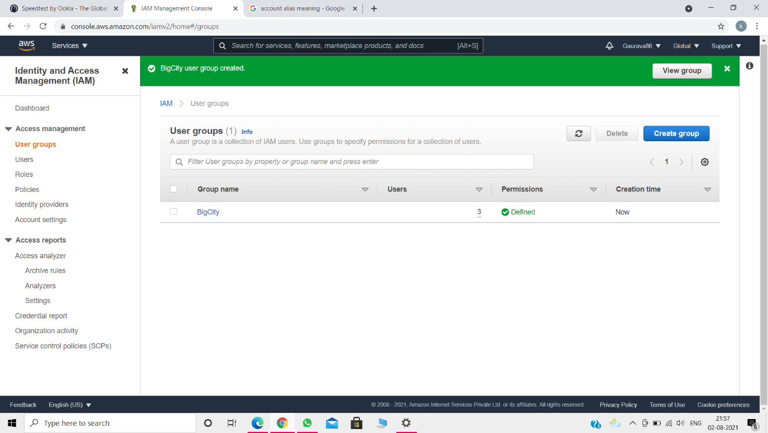
2. Set user permission –

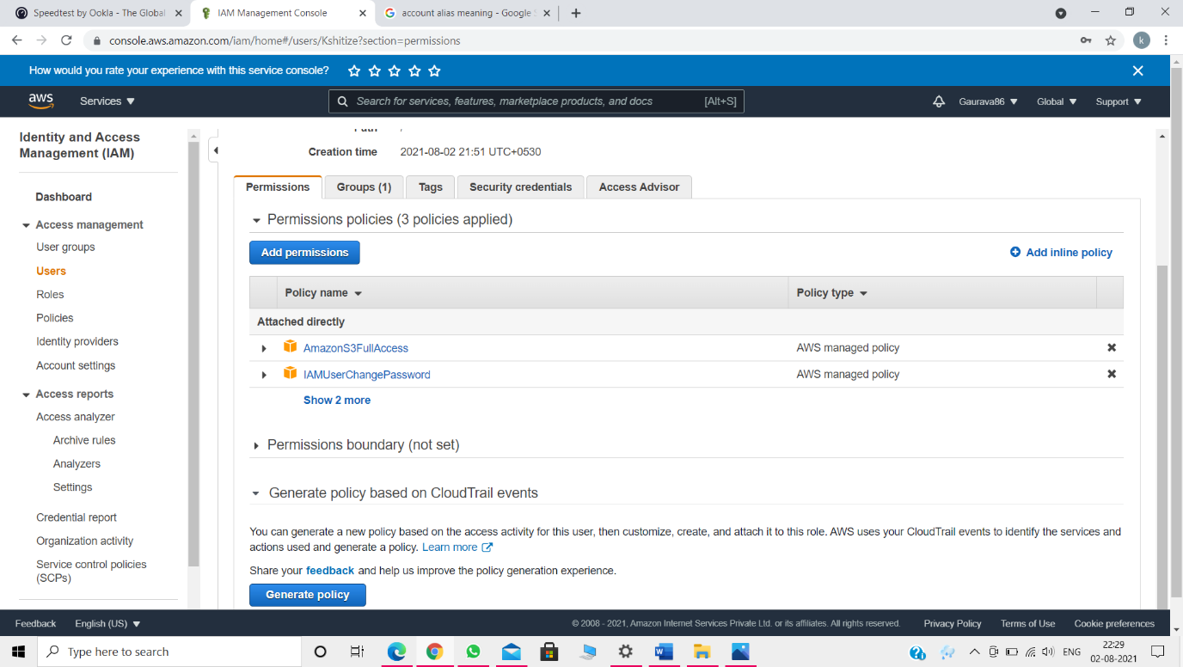

1. Set a unique group permission –

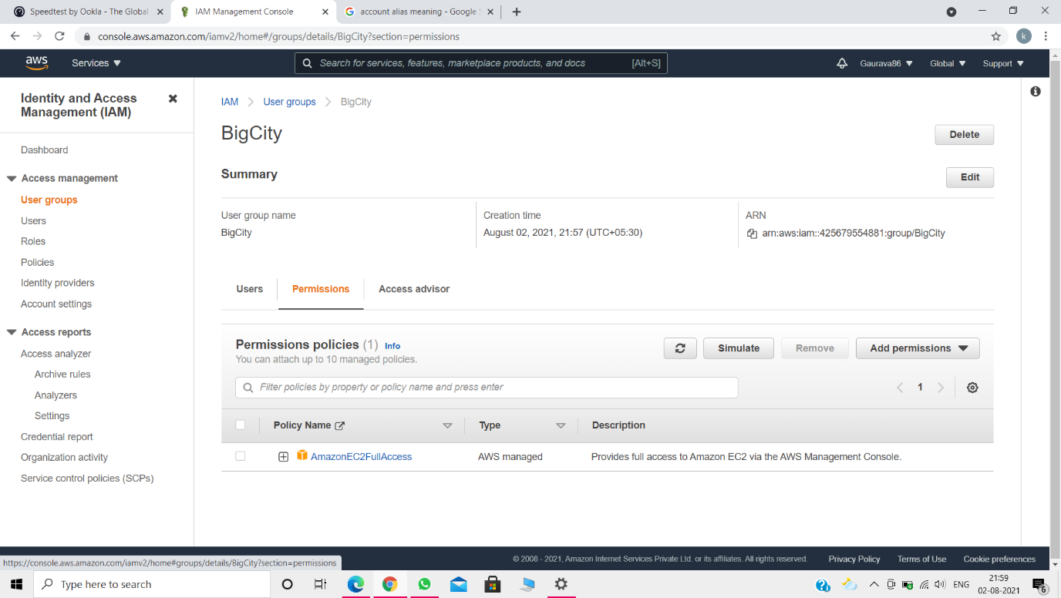

1. Login as iam user –

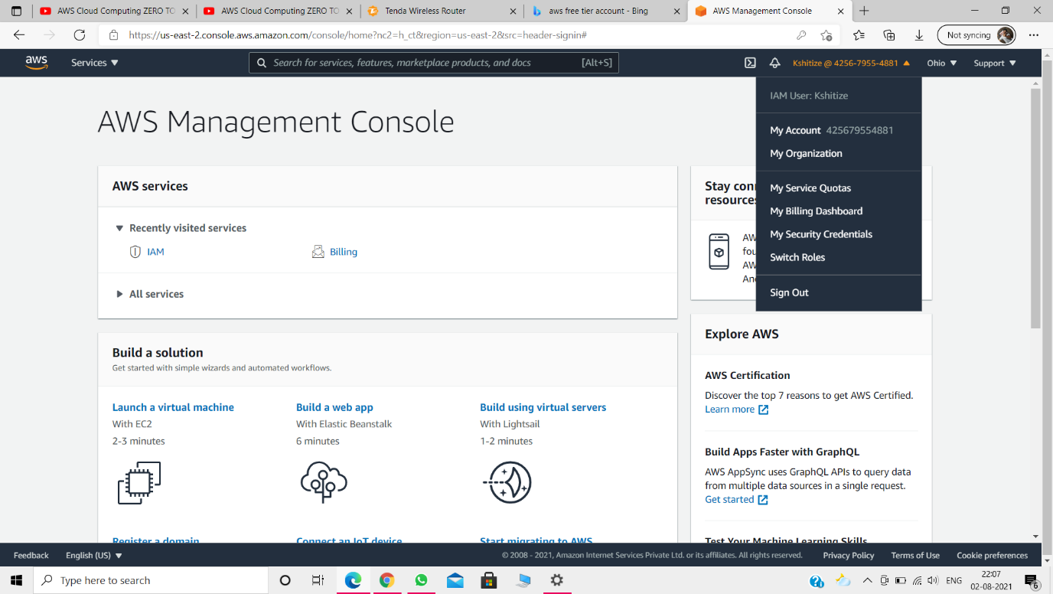

1. Show the user permission and group permission applied –

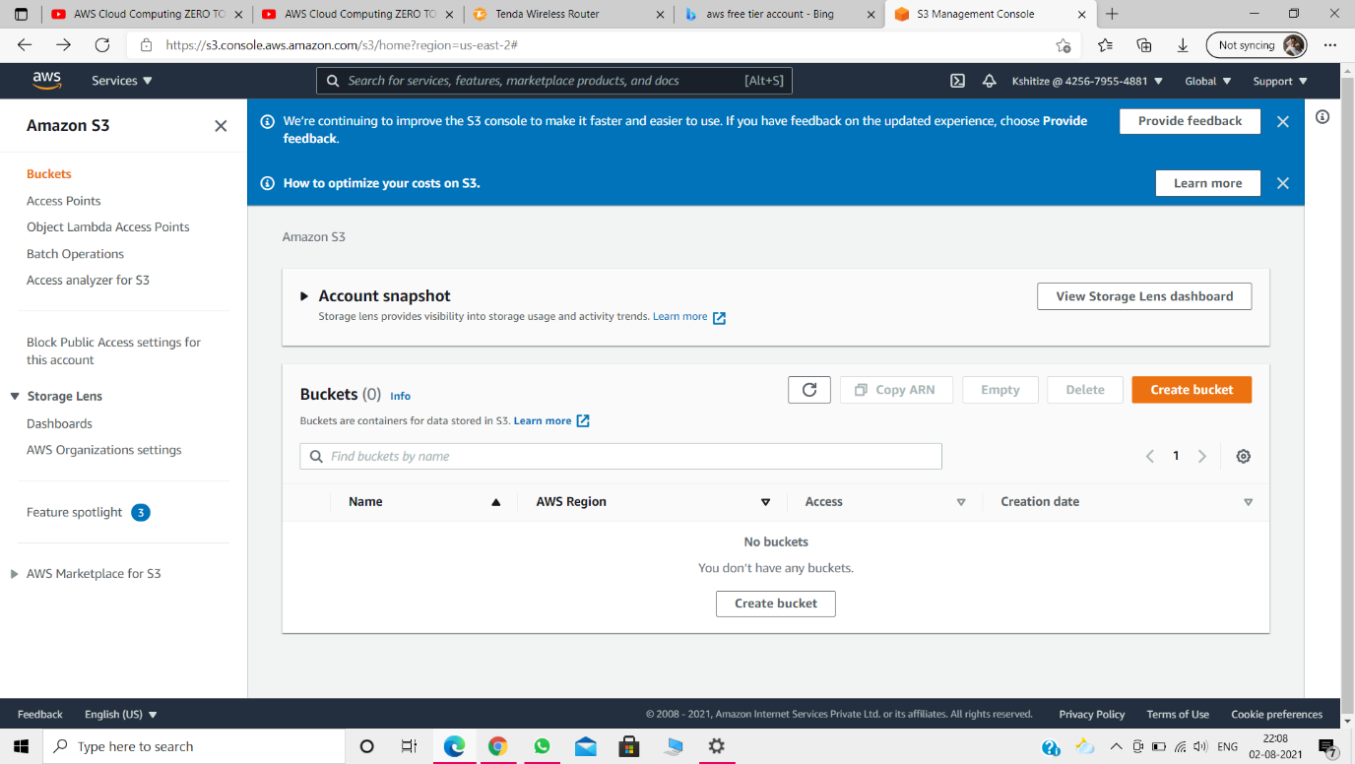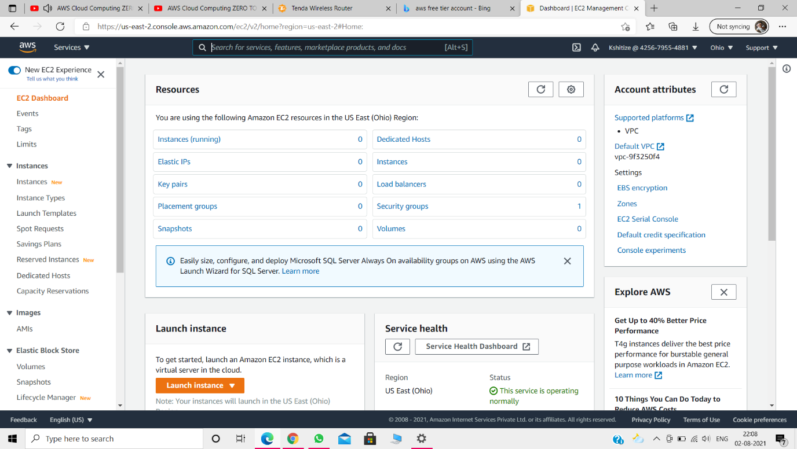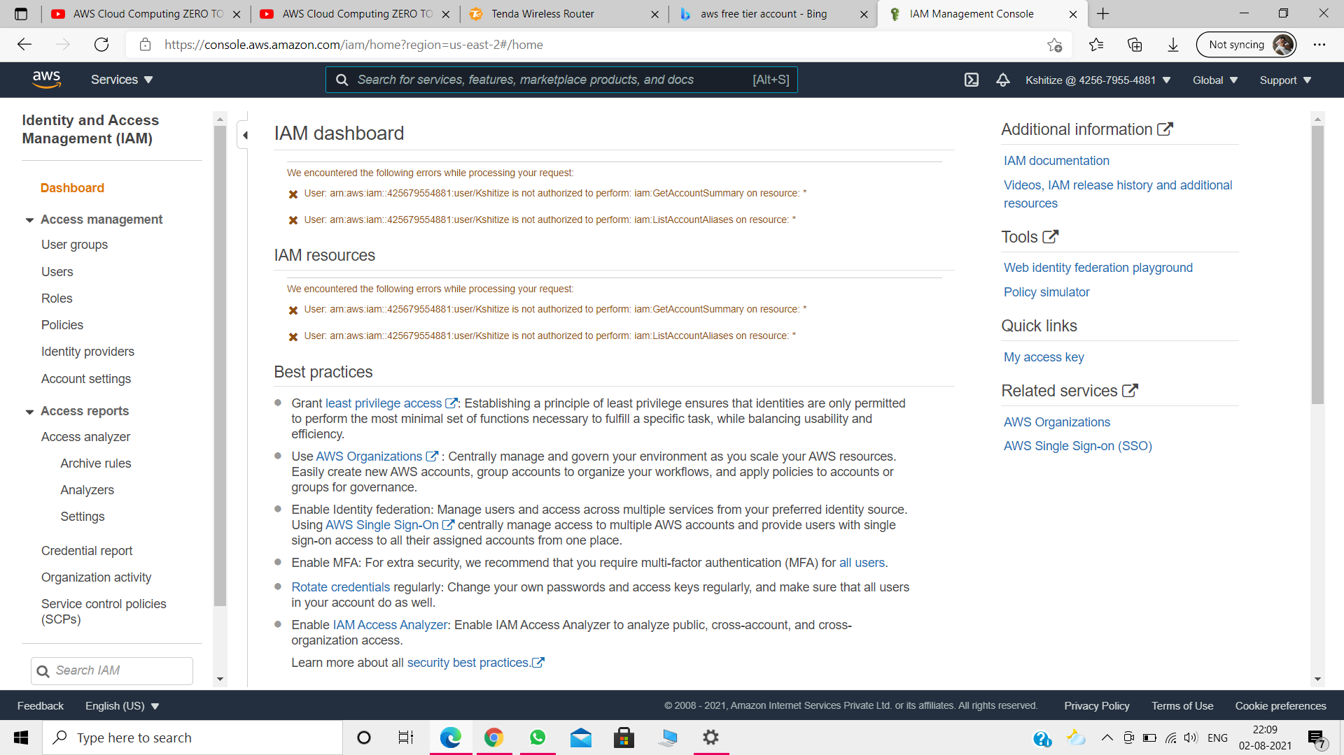

1. Check which policy give access to IAM –

 you must attach both a trust policy and an identity-based policy to an IAM role.